Expt No:  05 | PLC PROGRAMMING AND APPLICATIONS -I
Date:
/ /2025

- AIM:
To design and write ladder logic programs for various industrial automation scenarios involving timers, counters, and process control logic.
- CASCADING CLOCK COUNTER:

  - PROBLEM STATEMENT:
Develop a ladder logic program to implement a cascading counter system. A timer will increment a first counter's accumulated value by 1 every 60 seconds. When this first counter's accumulated value reaches 60, it must reset and simultaneously increment a second counter's accumulated value by 1. The 2nd counter must reset when its accumulated value reaches 12.
  - LADDER DIAGRAM:

  - I/O MAPPING:

- AUTOMATED LIQUID MIXING PROCESS:

  - PROBLEM STATEMENT:

Design a ladder logic program to automate the batch mixing process illustrated in the provided figure. The process must be controlled by a normally open Start button and a normally closed Stop button. The operational sequence is as follows:
- Pressing the 'Start' button shall energize Solenoid A to begin filling the tank.
- When the tank is full, a 'Full level sensor switch' closes, which must de-energize Solenoid A.
- Simultaneously, an agitate motor must start automatically and run for a duration of 3 minutes.
- After the 3-minute agitation, the motor must stop, and Solenoid B must be energized to empty the tank.
- When the 'Empty sensor switch' opens (indicating the tank is empty), Solenoid B must be de-energized. The system is then ready to repeat the sequence upon the next press of the 'Start' button.

  - FLOW DIAGRAM:
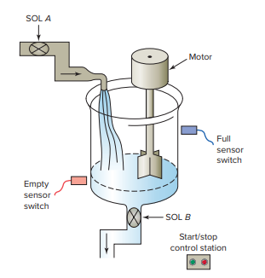
  - LADDER DIAGRAM:

  - I/O MAPPING:

- SEQUENTIAL LIGHT FLASHER WITH COUNTER:

  - PROBLEM STATEMENT:
Write a PLC program to operate a light according to a specific repeating sequence, initiated by a momentary push button. The sequence is as follows:
- The light is switched ON and remains ON for 2 seconds.
- The light is then switched OFF and remains OFF for 2 seconds.
- After this ON/OFF cycle is complete, a counter is to be incremented by 1. This entire sequence must repeat for a total of 4 counts. After the fourth count, the sequence must stop, and the counter must be reset to zero.

  - LADDER DIAGRAM:

  - I/O MAPPING:

- DUAL TANK FILLING SYSTEM:

  - PROBLEM STATEMENT:
A pump is to be used to fill two storage tanks, and the process is manually started by an operator from a start/stop station. Construct a PLC program to automatically control the filling logic. When the first tank is full, the program must stop the flow to the first tank and redirect it to the second tank, using sensors and solenoid valves. When the second tank is full, the pump must shut down automatically. Indicator lamps must also be programmed to signal when each respective tank is full.

  - FLOW DIAGRAM:
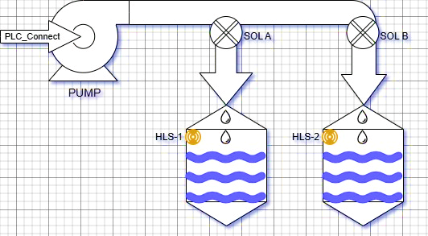
  - LADDER DIAGRAM:

  - I/O MAPPING:

- DELAYED LIGHTING CONTROL:

  - PROBLEM STATEMENT:
Write a program to implement a delayed lighting-off sequence for a building. When the main building lights are turned off, an exit door light is required to remain on for an additional 2 minutes. After the exit door light has turned off, the parking lot lights must remain on for an additional 3 minutes before turning off automatically.

  - LADDER DIAGRAM:

  - I/O MAPPING:

- CONVEYOR PART COUNTER:

  - PROBLEM STATEMENT:
Construct a PLC program to calculate the total number of parts on a main conveyor, which is fed by three separate feeder conveyors. The part count from each of the three feeder conveyors is available in a separate input register within the PLC. The program must use a timer to update the total count every 15 seconds. The logic must obtain the sum of the three registers and store this total in a designated output register.

  - FLOW DIAGRAM:

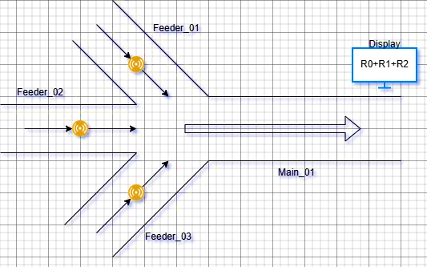

  - LADDER DIAGRAM:

  - I/O MAPPING:

- RESULT:
Thus, ladder logic programs for various applications using timers, counters, and sequential logic were successfully designed and prepared for testing.

